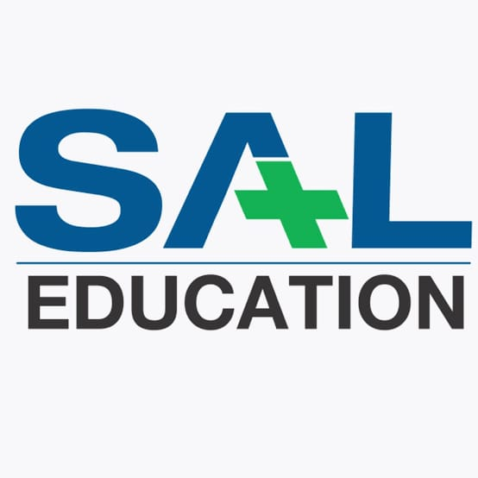

SAL INSTITUTE OF TECHNOLOGY AND ENGINEERING RESEARCH, AHMEDABAD
Affiliated to: Gujarat Technological University
College Code: 578

This is to certify that Mr. MANDLI GAURAVBHAI A of FYMCA SEM 1 has satisfactorily completed his academic project work report on GAURAV FURNITURE as a part of course prescribed by GUJARAT TECHNOLOGICAL UNIVERSITY for the academic year 2024– 25.
Enrollment No.: 245780694027
Exam Seat No.:

Date:

Project Guide Head Of Department(SALITER)

(Dr. Shraddha Garg) (Dr. Khyati Rami)

